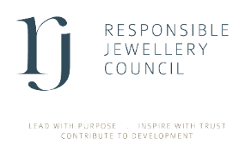
Commercial Member

New Entity or Merger

Name of member company

DETAILS OF NEW ENTITY

Name of entity | City, Country | Description of business activity | No. of Employees | RJC materials in scope

DIRECTORS & ULTIMATE BENEFICIAL OWNERS
Please enter the details for all shareholders that own 20% or more shares of the new entities and all Board Directors of the new entities.
Contact name: | Job title:
DOB: | Email:

Contact name: | Job title:
DOB: | Email:

Contact name: | Job title:
DOB: | Email:

Please submit this declaration to membership@responsiblejewellery.com together with all required documents outlined in our checklist.

4. Declaration
I declare that to the best of my knowledge and belief the information provided is complete, accurate and up to date.
I confirm that I have provided all the required documents as outlined in RJC’s checklist.
Signed: Name: Date:

Position: Date:

